LAB PROGRAMS

1. Write a program in LEX to recognize different tokes:Keywords, Identifiers, Constants, Operators and Punctuations.

CODE:

%{
#include<stdio.h>
%}
keyword[int|float|char]
alpha[a-zA-Z]
digit[0-9]
oper[+|-|*|/|%]
punc[.|?|,|!]
%%
(float|int|char) printf("Keyword");
{digit}* printf("Constant");
{alpha}({digit}|{alpha})* printf("Identifier");
{oper} printf("Operator");
{punc} printf("Punctuation");
%%
int yywrap()
{
}
int main()
{
printf("Enter input");
yylex();
return 0;
}

OUTPUT:

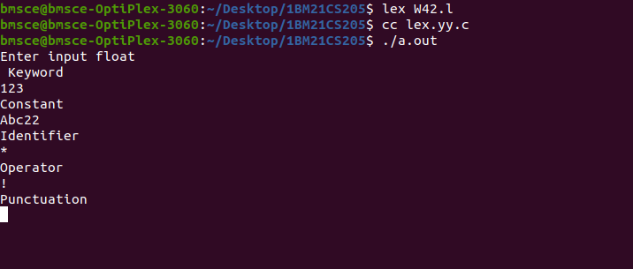

2.

